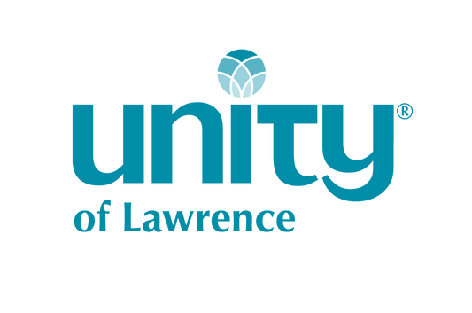

Annual Report

for 2019

Table of Contents

Table of Contents 1
UOL Annual Meeting Agenda 2
UOL Annual Meeting Minutes for 2019 2
From the 2019 Board President 6
2020 By-Laws Revision Proposal 8
2020 Nominees for the Board of Directors 9
2020 Proposed By-Laws Waiver 10
2019 UOL Board of Directors 10
2019 New Members Welcomed 10
UOL Consulting Minister 11
In Remembrance 11
Life in Our Community: Team Reports 12
Building and Grounds Team 12
Chaplain Team 13
Finance Team 13
Hospitality 13
Marketing Team 13
Music and Sound Team 14
Outreach Team 15
Welcome Team 15
Youth Ministries 16
2019 Treasurer’s Finance Summary Report 18
2019 Income and Expense Statement 19
2019 Balance Sheet 22
2019 Monthly Income and Expense Summary 23
2020 Proposed Budget 25
2020 Budget, continued 26

UOL Annual Meeting Agenda
January 19, 2020
- Call to Order
- Opening Prayer
- Approval of Agenda
- Determination of Quorum
- Approval of Minutes from Annual Meeting, January 20, 2019
- President’s Report
- Treasurer’s Report
- Revision to UOL By-Laws
- Announcement of Board Candidates
- Vote on By-Law Waiver for New Board Members
- Election of New Board Members
- Election of Congregational Representatives for 2020 Nominating Team
- Congregational Representatives for Finance Team
- Recognition of 2019 Board Members
- In Gratitude
- Closing Prayer
- Adjourn

UOL Annual Meeting Minutes for 2019

Unity of Lawrence (UOL)
Annual Congregation Meeting Minutes
January 20, 2019

Board member Gail Ishmael and Vice President Cheryl Miller verified membership status in the foyer and passed out ballots to the 23 active members for use in motions and voting.

President Michelle Kirk officially called the meeting to order at 12:32 pm. Rev Shawn prayed us in.

Approval of Agenda
Cheryl Miller motioned to approve the Annual Congregation Meeting agenda. Gail Ishmael seconded. The motion passed unanimously.

Determination of Quorum
UOL presently has 69 active members. By-laws require at least ten percent present, which the presence of 23 members met sufficiently.

Approval of Minutes from Annual Meeting January 21, 2018
Kathy Pryor motioned to approve the minutes with Jessica Pryor seconding the motion. Motion passed unanimously.
President’s Report
President Kirk acknowledged Sharon Dwyer’s volunteer spiritual leadership during the transition from Rev. Sherrie Taylor-Jones’ departure in February and the hiring of Rev. Shawn Ann Wegner in September. Sharon lined up speakers each week, coordinating their talk titles/descriptions for the office manager. As a Licensed Unity Teacher, she also provided services for two of our congregants who passed. (Please forgive the error made on the printed annual report; Sharon also corrected the intended mention of Beverly Noonan by Michelle’s report, accidentally listing Ann Nunley instead!) All those who have stepped up in some volunteer capacity in the past year were asked to stand and be recognized. Nearly everyone rose! Cathy Moreland was also recognized as our amazing office manager, keeping logistics running smoothly and efficiently.

Treasurer’s Report
Kathy Pryor, Treasurer, acknowledged and thanked Polly McCall for all she does explaining the spreadsheets so all can better understand the finances of UOL. On page 10, where the projected income for UOL was outlined, explanations followed. To prepare UOL’s budget for 2018, congregants were asked to turned in pledge cards with their projected tithes. The pledges totaled $93,129.96, of which $73,112 was actually contributed to UOL, leaving a discrepancy of $20,017.96.

UOL’s projected income for 2018 was $121,581.58. Our actual income was $94,487.62. UOL has less monthly income now that the Seventh Day Adventist no longer rent the building and at least one major contributing family moved away. The treasurer’s report refers to the cash balance sheet. UOL’s subtotal of cash at the end of 2017 was $27,392.26. At the end of 2018, our balance was $16,696.68. Polly explained that the reserves have slowly been used to pay monthly expenses when income and tithes have been too low. She acknowledged the Board doing a good job keeping expenses down, even lower than expected, in order to help.

Diane Silver asked what we did we not do that saved on normal expenses. Polly answered by explaining that we had a reduction in minister salary due to no minister for eight months, hiring Rev Shawn as part-time, and not spending the marketing budget of $500 this past year. She also added that UOL spent $828 for Holly Taylor to attend the 2019 POSI music conference. This money came out of the 2018 balance but is actually part of the 2019 budget, saving hundreds of dollars by doing so.

Linda Sneegas asked, “If the status quo continues, what can we expect?” Polly answered by explaining we would no longer have savings and would end up in the negative. At that point, we would have to consider selling the building and losing Rev Shawn, as UOL would not be able to offer her a contract. Linda commented that insufficient funds seems to be conversation at every annual meeting. Rev. Shawn reminded everyone that the issue of lower membership numbers is not just an issue for UOL. It is a national issue of declining attendance and tithing at churches in general. Stephanie Barrows suggested that as communities change and no longer fit churches, maybe the churches need to change to connect with the community needs.

Jo Andersen relayed a conversation she had with someone who was proud to tell her how they had budgeted $5 each week to tithe to UOL. She suggested we may need to remind all congregants just what is needed in contributions to sustain UOL. Rev Shawn researched finances. Presently, with 69 members, we would need $166 each month or $1992 per year from each congregant to meet our 2019 expenses. Robin Joseph responded that we’ve explained what is needed financially from congregants before.

Polly affirmed that we should talk in Prosperity Conscious language, not “lack” or “need.” Linda expressed that people will pay to hear outstanding messages. We still have lots of members who haven’t come back over various new ministers/transitions. Linda suggested perhaps they are not getting the messages they need. Michelle reminded all that with the service being provided on Facebook Live, viewing can be done from anywhere without having to be in the building on Sunday mornings.

Deanna Burnett felt one of the missed opportunities is marketing. We created products that were not followed through and put to use. Mikayla Schmitz asked that if UOL did not use the marketing budget last year, why not use it or decrease it? Kathy Pryor acknowledged that marketing and membership both need to be priorities next year. Along that thought, Stephanie suggested the marketing of UOL could better be done by being more active in the community. Polly reinforced that significant changes and raising consciousness were vital.

Michelle and Kathy reminded all that these are items further along the agenda and that reports needed to be approved first. Kris Hicks moved to approve the Treasurer’s 2018 budget report, Diane seconded; motioned passed unanimously.

2019 Budget
Kathy presented the proposed 2019 budget for UOL. Michelle let the congregation know that Rev Shawn, knowing the finance issues of UOL, has offered to take the summer months off to spend time with her family and recharge [saving us the expense of her part-time salary].

Gail asked for an explanation of “groups” for income on the budget proposal. These are the AA 12-step groups who hold weekly meetings, Vortex, Deep Listening Sangha, etc. Janet Gerstner reminded all that Seventh Day Adventists is one of those groups that no longer rents from UOL.
Polly reminded all that if the budget was not approved, there wasn’t much else that could be done about it at this point. Janet got clarification that as the year progresses, UOL would be allowed to make changes to the budget as needed. Polly reinforced that substantial adjustments were necessary in maintaining the status quo and meeting the proposed budget.

Carol March commented that UOL does not do enough marketing, reminding us that it makes us forgettable with the Lawrence community. She asked what World Wide Ministries does to help promote UOL, since we tithe regularly to them. Rev Shawn answered that besides creating the common branding that UOL uses as a common logo, she wasn’t sure but would look into it.

Bonita Yoder asked for the breakdown in staffing expenses. Polly told her that it was confidential but made us all aware that UOL pays extremely low in comparison to the average. Rev Shawn mentioned that as a new minister aware of expenses, the Board has not in any way allowed for any waste of funds. Cheryl Miller motioned to accept the 2019 budget as proposed, Diane Silver seconded, and the motion passed unanimously.

Attracting Alternative Income Sources Task Force Invitation
Michelle explained that this new task force is a call to action for members and congregants to work quickly for a very short time period, finding renters who would utilize the building when space is available. She also reminded potential members of this task force that UOL already has building usage forms readily available. UOL is keeping Prosperity Consciousness in mind for a quick turnaround within two months’ time. Those interested in working on the AAIS Task Force are Bonita Yoder, Stephanie Barrows, Carol March, Gail Ishmael, and Karen Langsford.

Visioning Team Invitation
Cheryl invited all congregants interested to be on the Visioning Team (formerly only the Marketing Team) to help decide what will help UOL grow. She expressed that the term “marketing” may not appeal to those who would otherwise think of offerings UOL can provide, “what is cool that others want to be a part of, keeping in mind our vision of what UOL is, and growing to become.” Rev Shawn said this team could explore the marketing resources available through UWM at www.unity.org. She did not believe, however, there was marketing support for each individual church. Interested in pursuing visioning and/or marketing are Kathy Pryor (marketing lead), Mikayla Schmitz, Deena Burnett, Diane Silver, and Linda Sneegas.

Announcement of Board Candidates
Jessica Pryor, chair of the UOL Nominating Committee, presented the new candidate slate for the 2019 board: Michelle Kirk, Karen Langsford, Mikayla Schmitz, and Diane Silver. Cheryl read the by-laws as pertaining to nominees. Members submitted ballots to Cheryl and Gail. Cheryl announced shortly after counting that the entire slate was elected.

Election of Congregational Representatives for 2019 Nomination Team
Jo Andersen agreed to be next year’s nomination team representative with Janet Gerstner as alternate. They will not need to meet until September of 2019, along with the minister and at least one Board member.

Congregational Representatives for Finance Team and/or Bylaw Revision
Michelle invited any/all active members who wished to review the current by-laws to be a part of the review process the Board was initiating. (UOL By-laws were last revised/amended in 2014.) Cheryl volunteered to do so.

Recognition of 2018 Board Members
Cheryl Miller, Roger Houck, and Ginger Scalet were acknowledged and blessed for all their hours of service on the Board of Directors for UOL. (Gifts were presented privately, since Roger Houck had already moved away and Ginger was unable to attend.) Janet Gerstner wanted to recognize the whole 2018 Board for outstanding work. Rev Shawn also thanked President Kirk and Cathy Moreland for helping her be successful during her first five months at UOL.

Closing Prayer
Rev Shawn prayed us out.
Adjourn
Janet moved to adjourn the meeting. Karen Langsford seconded the motion, which unanimously passed. The meeting was adjourned at 1:38 pm.

Respectfully submitted,
Marsene Feldt, substitute secretary

From the 2019 Board President

Dear Ones,

It has been an amazing year at Unity of Lawrence—a year of transition and joy as well as the completion of long-needed repairs to our building. We entered 2019 with uncertainty about our prosperity, went into the summer worried that we might go bankrupt, and then finished the year with a healthier bank account than we've had in quite a while. We had to say goodbye to old ways of doing things, but in doing so we also discovered that the loving members of this congregation actually do fulfill the promise we make to ourselves every Sunday when we recite our mission statement: We are a thriving spiritual community.

The most fundamental change came on July 28, 2019, in a special membership meeting when the congregation responded to our financial crisis by voting overwhelmingly to transition from a minister-led congregation to one where the members of the congregation take responsibility for the practical work and spiritual life of Unity of Lawrence. The vote meant that we would be able to keep our building instead of having to sell it, but it also meant sadness because it meant we would have to release our beloved part-time pastor, Rev. Shawn Wegner. Rev. Wegner served us well in her months at Unity of Lawrence. This wasn't a change that we wanted, but in a heartfelt and thoughtful discussion at the July 28 special meeting, the members of the congregation determined that if we lost our physical home, we might never be able to again afford a building in the expensive Lawrence real estate market. Our membership decided that changing to become a congregation-led church was the only course of action we felt comfortable taking. The congregation was blessed to be able to say a formal goodbye to Rev. Shawn in a special Sunday service several weeks after the membership meeting.

Running a congregation without a minister brought new challenges. Because the Unity of Lawrence Board is made up of volunteers, none of us has the time to take on the role of completing all the practical tasks that have to done to run a church. We needed to create a new staff position to coordinate our community, including lining up guest speakers for our Sunday services. Unity of Lawrence was blessed to already employ Cathy Moreland as Office Manager. The Board was extremely pleased when Cathy agreed to expand her work at Unity and take on the duties of being the Congregational Coordinator as well as Office Manager. Since taking over that job in August, Cathy has filled our calendar with amazing guest speakers and made certain that all of our practical needs have been met. Cathy's work has been supervised by a Sunday Service Committee of Board members made up of Michelle Kirk, Kathy Pryor, and me.

In the fall, The Board also voted to create a new role that we are calling Consulting Minister. This enables us to include an ordained and experienced Unity minister in Board meetings and to have this person on call to provide advice on guiding the spiritual life of Unity of Lawrence. In December, the board was delighted to learn that Rev. Edna Mosher had agreed to take on the role. Rev. Edna and her husband, Rev. David Mosher, served as co-minister of Unity of Lawrence from November 2013 until April 2015. (More information on Rev. Edna is available later in this report.) We are paying Rev. Edna a modest stipend of $125.00 a month.

Our new-found prosperity and energy, has also enabled Unity of Lawrence to make long-needed repairs to our building. We put on a new roof. We ran a successful fundraising campaign that quickly paid for two new water heaters and other repairs needed on the building. A thousand thanks to all the donors and to Board Member Kathy Pryor for ably leading the campaign and to Board Member Gail Ishmael for creating the campaign logo.

Unity continues to seek greater prosperity. We worked with real estate agent Kirsten Flory of Colliers International to find tenants to rent our lower level and the two unused, upstairs offices for use during times when the congregation is not using the church. In an effort to give us greater flexibility, we were also able to change the zoning for our property from RS7 to RSO. We won final approval for our new zoning from the Lawrence City Commission in October.

We complete 2019 as a rejuvenated congregation. Attendance is steady and the energy of our services has been strong and joyful. Unity of Lawrence continues to host workshops and classes. We continue to enable our members to expand their skills and experiences by again bringing musician Kelley Hunt on board to host our Christmas Choir. The Board began exploring a closer relationship with The Light Center, a Unity ministry that runs a retreat center outside of Baldwin City, KS.

Given the financial troubles we faced at the beginning of 2019, we should have failed as a congregation, but we didn't. We should have given up, but we didn't. We should be struggling now, but we aren't. As a new year and a new decade dawn, Unity of Lawrence is stronger than ever. Our future is filled with opportunity. I can't wait to see what 2020 brings.

Thank you all for committing to this journey.

Gratefully, in love and light,
Diane Silver, Board President

2020 By-Laws Revision Proposal

3.3 Term of Membership.
3.3.1 Active Member.
3.3.1.1 New Members. After acceptance as a new member, as outlined in Section 3.2, each member shall have voting rights at all membership meetings, up through and including the next regularly scheduled annual membership meeting after joining the church .
3.3.1.2 Existing Members. To retain active membership rights, each member must provide up-to-date contact information to the church. indicate his/her desire to remain a member by completing and returning to the church, either in person, by mail, email or other commonly used verifiable means of communication, a yearly membership renewal card or such other document as approved by the Board of Directors.
3.3.2 Inactive Membership.
3.3.2.1 Inactive Status. If no current membership renewal card or approved document is on file prior to the annual membership meeting, that person becomes inactive and cannot serve on the Board of Directors or vote at any membership meeting.
3.3.2.2 Reinstatement of Inactive Membership. After becoming inactive:
3.3.2.2.1 Within the first two years, one may regain membership if they have accrued the attending of four (4) Sunday services. One must then fill out a yearly membership renewal card.
3.3.2.2.2 After two years, one must reapply for active membership in accordance with Section 3.02
3.3.2 3.3.3 Removal of Membership
3.3.2.1 For Inactive Members. After two years of inactivity, a person is removed from membership upon approval of the board.
3.3.3.2 For cause. Removal from membership of a person whose qualifications are in question requires at least a two-third (2/3) affirmative vote of the Board of Directors, including agreement by the minister(s). Prior to action concerning removal, the person must be notified by certified mail and be given an opportunity for a hearing with the board.
3.3.3 3.3.4 Active Members will hereinafter be referred to as “Member”.

2020 Nominees for the Board of Directors
As stated in Unity of Lawrence By-laws, Section 4.4.1, any person elected to the Board of Directors must be a Member of Unity of Lawrence.
He/she will be a person who is
- willing to serve on the Board; endeavors to live in accord with the Jesus Christ principles of love and truth as taught by Unity;
- furthers the work of this Ministry through his/her active interest, love, and financial support;
- is a sincere and continuing student of Unity, conversant with its teachings;
- has demonstrated leadership capabilities;
- has been a member of Unity Church of Lawrence for at least one year; and
- is in attendance at the annual membership meeting, or in the case of the inability to attend, has submitted a letter of willingness to accept election to the Board.

The 2019 Nominating Chair, Jo Andersen, served with Michelle Kirk and Mikayla Schmitz on the Board Nominating Committee. This is the slate proposed by the Nominating Team:
David Geyer: David is a long-time member of UOL and is committed to supporting the continuing vision of Unity of Lawrence. By nurturing and growing Unity’s connections with the community we can continue to make a difference in Lawrence.

Cheryl Miller: Cheryl has served on the board twice before and she welcomes the opportunity to serve again. Her vision sees our community going deeper into gratitude and stewardship which aligns with the Law of Attraction. She loves Unity and the non-denominational inclusiveness that is shown every Sunday.

Janet Morgenstern: “I am honored to be considered for a board position. I take this commitment very seriously. Unity of Lawrence has helped me to grow tremendously this year, and I am committed to giving back to this organization, from the bottom of my heart.” Janet truly believes the meaning of life is to make the world a better place to live for everyone. She views UOL as a dynamic group of people with unlimited opportunity and a few meaningful challenges. During her time on the board, Janet would focus on financial concerns, new member recruitment, and providing spiritual support to the family during these stressful times. Janet is also a Sunday greeter at UOL.

John Pryor: John is committed to Unity’s founding principle and UOL’s vision and mission. He believes in a world that works for everyone. John’s vision is to grow UOL’s membership and continue to support all the people and programs at UOL. John is also a worship assistant on the first Sunday of the month.

2020 Proposed By-Laws Waiver

In order to add two new members to the UOL Board, we need to vote to waive two aspects of our by-laws. In both instances, we have a good reason for doing so.

The first waiver will enable us to add John Pryor to the UOL Board. John is an active member of UOL who will bring a new perspective to the board and experience in facilities repair and management. Unless we waive the provision in our by-laws that states that two people who are closely related cannot serve on the board, he will be unable to bring his leadership skills to UOL. Currently, John's sister, Kathy Pryor, serves on the board. In her term, Kathy has proved to be invaluable. We believe that UOL needs both of their voices, and we also know that on a seven-member board two people are not even close to a majority. We do not see any problem in having two Pryors in serving at the same time.

The second waiver will enable us to add Janet Morgenstern to the UOL Board. Janet is another active member who will bring a fresh perspective to our leadership. Unless we waive the bylaw provision that states a board member must have been a member for a year, Janet will be unable to serve. Although Janet has not yet been a member for a full year, her commitment to UOL is already clear. We know she will be a strong addition to the UOL Board.

2019 UOL Board of Directors

Diane Silver, President
Marsene Feldt, Secretary
Mikayla Schmitz
Karen Langsford, Vice President
Gail Ishmael
Michelle Kirk, Treasurer
Kathy Pryor

Our heartfelt thanks to Michelle Kirk, Marsene Feldt, Gail Ishmael and Mikayla Schmitz
for their service to the Board in 2019.
You are amazing bridge-builders, sharing your love in service to Unity of Lawrence!

2019 New Members Welcomed

Elaine Carlson
Pat Frank
Ann Furlong
Becky Ludy
Barbara Morgenstern
Janet Morgenstern
Cinnamon Ramer
Alan Winslow
Sonja Winslow

UOL Consulting Minister
Rev. Edna Mosher

The Unity of Lawrence Board of Directors hired the Rev. Edna Mosher in the fall of 2019 to serve as our consulting minister to provide advice on the spiritual and practical life of our congregation. She officially begins her service in January 2020, and will receive a modest stipend of $125.00 per month.

While engaged in a successful career managing domestic and international Customer Service operations in the biotechnology industry, Rev. Edna found Unity in 1994. After launching the youth education program at Unity in Frederick, MD, beginning a weekly prayer service, and then serving on their Board of Trustees, she began her path towards ministry, becoming a Licensed Unity Teacher in 2003 and an ordained Unity Minister in 2006.

With her husband, Rev. David, they were pioneering co-ministers at Unity in Leesburg, VA, from 2006 to 2012. A year after moving to Lawrence to be closer to the Mosher family, Rev. Edna began guest speaking and subsequently served part-time with Rev David as co-minister of Unity of Lawrence from November 2013 until April 2015.

Rev. Edna works full-time in the electronics industry, serves on the board of her local neighborhood association and on Unity Worldwide Ministries’ Admissions Team, as well as supports others with spiritual counseling. One of her greatest joys is spending time with her five grandchildren who all live in Lawrence.

In Remembrance

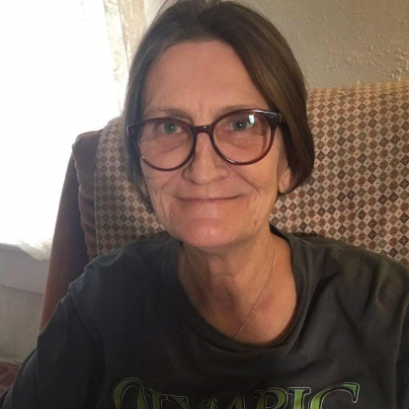
Beverly Schuster

Life in Our Community: Team Reports

Building and Grounds Team
Team Leader: Marsene Feldt

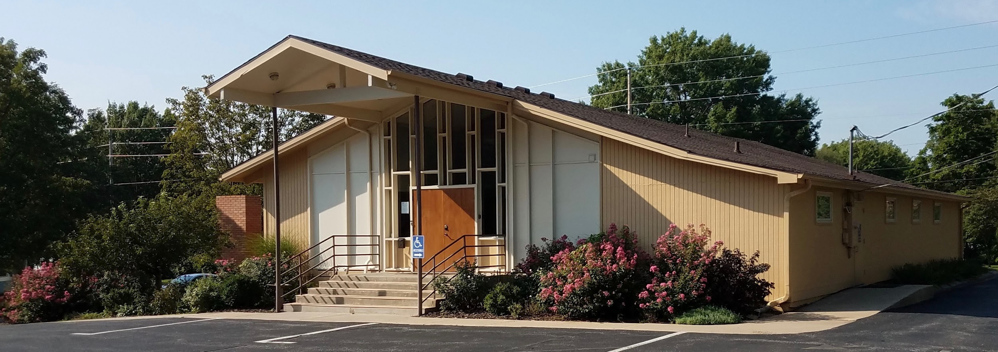

Once again, UOL had its share of eventful happenings due to record rainfall in the spring which led to subsequent water damage inside the building and both of the hot water heaters going out.

Several members volunteered money, supplies and or labor for our annual Spring Beautification Day April 20. We weeded, trimmed, mulched, bagged, hauled and in general, got the grounds ready for all the growing and blooming that took place throughout the seasons. Thank you to: Polly McCall, Michelle Kirk, Carla Mumma, Kris Hicks, Mikayla Schmitz, Jan Spiegel, Linda Lake, Cathy Moreland, Lisa Miller, Pat Phillips, Nate, Maverick, Atticus and Marsene Feldt, and our neighbors who live in the former Annex!

The Feldts also donated their time every week mowing throughout the year.

Other improvements include: the termite damaged Peace Pole being refurbished and replaced; the pitted concrete and exposed rebar of the steps being resurfaced with a TREX-like material that matches the new building doors; and the roof being repaired and replaced by KSR Roofing.

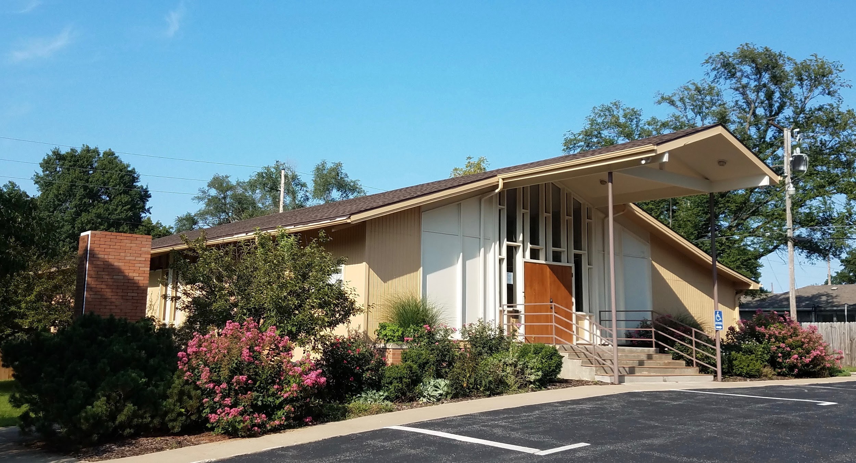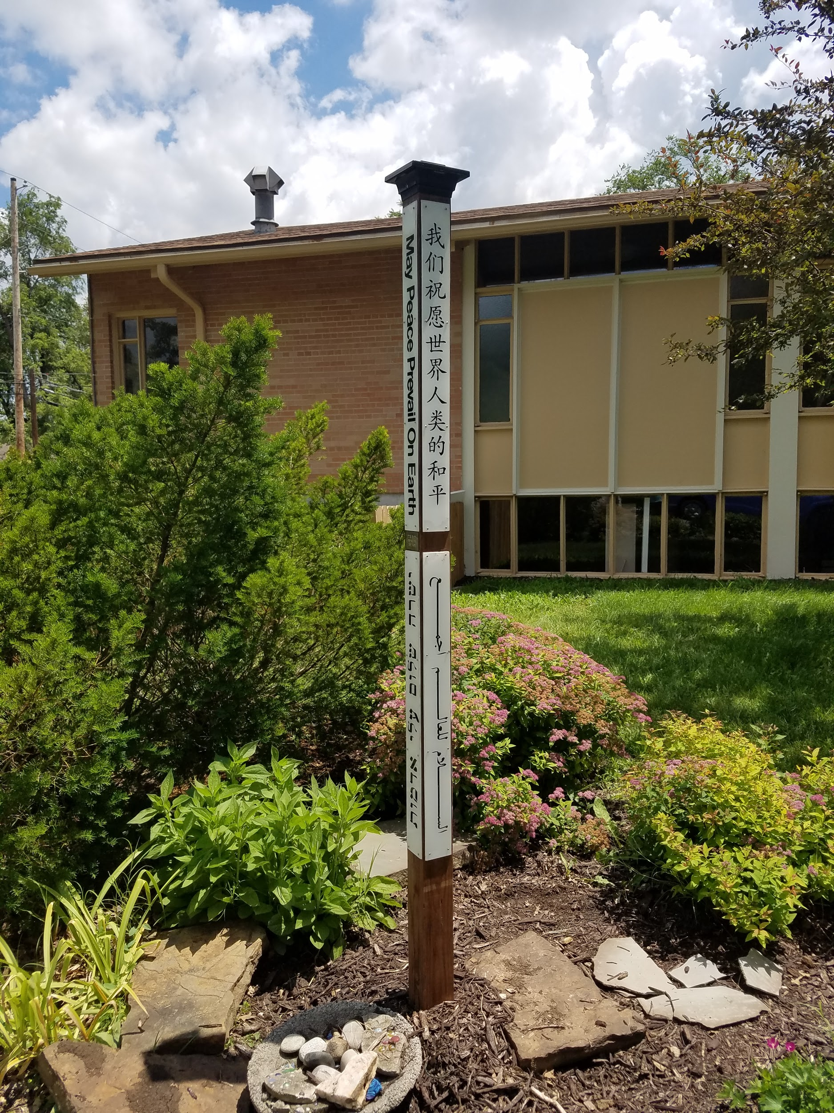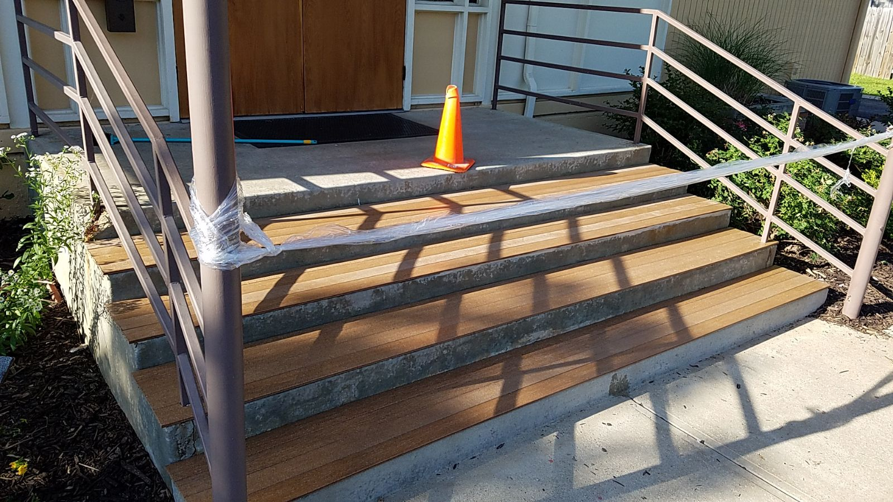
It was also discovered that UOL’s oven was no longer working. Colleen Riley found and gifted a replacement to UOL with the help of Cathy Moreland and Bettie Wilson.

Last but not least, after having no hot water in the building for six months, Kathy Pryor and Gail Ishmael worked on fundraising with the congregation to off-set the $8000 needed to replace the hot water heaters as well as redirect the roof drain that had been running across the northeast sidewalk causing treacherous slime mold to build-up and cause a slipping hazard for pedestrians. John Pryor worked on contacting the City of Lawrence and A & H Air Conditioning Heating & Plumbing to arrange for new hot water heaters that were installed, up to City code, in early December.

Chaplain Team
Team Leader: Karen Langsford
In 2019 our team of two chaplains, myself and JoAnn Qandil, kept us prayed up and for. They were able to attend a chaplain retreat in Atchison, KS, in the spring. The retreat was hosted by Rev. Kerri King of Overland Park Unity at the Benedictine Abbey. We look forward to adding to the chaplain team in 2020.

Finance Team
Team Leader: Michelle Kirk
The Finance Team in 2019 was comprised of Rev. Shawn Ann Wegner, Senior Minister for the first six months of the year; Michelle Kirk, Treasurer; Diane Silver, President; Carla Mumma, congregational representative; and Polly McCall, Director of Finance. The Treasurer’s Report and all the financial statements are in the final section of this Annual Report.

Hospitality
Team Leader: Gail Ishmael
The second Sunday pot lucks continue to be well attended. In the fall, Bettie Wilson joined the team as our new Kitchen Goddess and made certain the kitchen was organized and cleaned. Thank you, Bettie, for the thoughtful reorganization of the kitchen! It is clean and bright and welcoming. In December, congregant Colleen Riley purchased, donated, and helped install a new, used stove for our kitchen. Thank you, Colleen!

Marketing Team
Team Leader: Kathy Pryor
Marketing focused almost exclusively on Facebook in 2019, and saw an increase from 422 followers in 2019 to 524 in 2019. The number of people reached in 2019 was 4,700, and Unity enjoyed 232 responses on Facebook.

Marketing also focused on appropriate communication to raise $8,000 for building repairs. The campaign began on November 7, 2019 and ended on December 8, 2019 with a total of $8,100 raised.

Areas to improve for 2020 include:
- Scheduling marketing team meetings so that congregants have an opportunity to be involved.
- Use other social media platforms including Instagram and Twitter.

Music and Sound Team
Music Director: Holly Taylor
This past year I have focused on refining and continuing expansion of our guest musician list. I am excited to work with a professional level of musicians on a regular basis. These artists have come from near and far, some as a result of my attendance at the POSI Fest last year. I appreciated attending workshops at the POSI Empowerment Conference as well as master classes at the Song School. Rickie Byars was one of the keynote speakers and it was a treat to experience how she leads a Sunday service.

This year has marked big transitions for UOL, with the passing of our beloved sound tech, Bev Schuster, and the releasing of our pastoral format and Rev. Shawn Wegner. Through these events I believe we have held strong, and gained focus. Avery and Erin have been consistent with their services and are making themselves available as needed beyond. Thanks also to Michelle Kirk who has been available to help as needed in the sound booth through these transitions. Our songbird ensemble has undergone transitions as well with the passing of the guard from Rita Richardson and Deena Burnett over to Mikayla Schmitz and Jay Pryor. These transitions have been quite seamless and joy filled.

One highlight of our year was our volunteer appreciation service featuring a Sugarfoot Detour mini concert. Other highlights include our choirs with Kelley Hunt and Songbird Ensemble Sundays! In regards to music features at our acoustically amazing facility, I would still love to see further expansion of our churches interest in supporting the arts through concerts. We have been approached by many top Posi and folk artists throughout the continent, so we are on the map. I have made some of these connections through the POSI Fest, and other professional means, yet others have come to UOL as cold contacts. We haven't been at a place to support these artists at the financial levels needed to justify their travel based on our attendance. If we are to create bigger events, we will need to find community liaisons of support to increase event interest. If this becomes an interest, we are ready to pursue, I will be available to be part of the visioning team.

I continue to refine and keep watch over the service efficacy, and provide stage cues as needed during service. Sunday services are a living breathing organism, unique each time, but I feel comfortable in assisting with the flow and making suggestions as needed. I do get to listen to the congregant's feedback and it is generally a tone of gratitude!

Working with Cathy Moreland has been a treat, her support and assistance in creating ease and flow behind the scenes is worthy of special mention.

Thank you for your continued support, I love being a part of the team of Unity!

Outreach Team
Team Co-Leaders: Pat Phillips and Lisa Miller
The Outreach Team offers coordinated support for those who have a desire to serve. The Team identified projects, groups and programs in the community that need assistance, support and loving care. The projects are communicated to Unity members through email, bulletins, announcements, flyers and word of mouth. In 2019, there was an Outreach Project five months out of the year.
- March: Provided Noon Meal at Lawrence Interdenominational Nutrition Kitchen (LINK).
- July: Sponsored a “Pack a Backpack Project” providing needed school supplies for children in our community.
- October: Fall Food Gathering for the “Just Food” food pantry– filled the shopping cart to overflowing.
- November: Provided requested food for the “Community Thanksgiving Dinner” at Maceli’s on Thanksgiving Day.
- The first Friendsgiving Dinner at UOL was held on Thanksgiving Day. A big thank you to Bettie Wilson, Deena Wilson and Cathy Moreland for hosting – attendance was 15.
- December: Provided supplies and blankets to Drop-in and Rest Center (DARE) as well as giving thermal underwear and winter boots to DARE for Christmas presents.

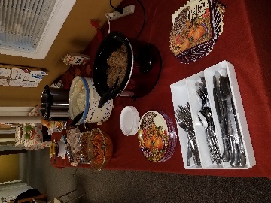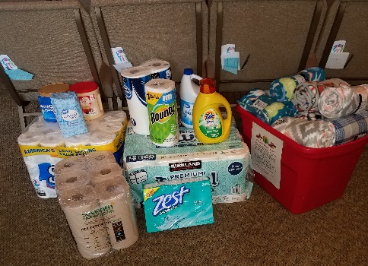
We look ahead to 2020 with open hearts to seek ways the Outreach Team can be a helping and loving presence in our community. We will continue to engage in familiar projects and welcome new ideas.

Welcome Team
Team Leader: Linda Dean
This has been an eventful year for the Welcome Team. As ushers we have taken on bringing flowers for the service. We also had a meeting regarding our duties as ushers and welcome team members to refresh old members of the team and bring new members up to speed. The fifth Sunday was recently taken up by Sharon Dwyer. Janet Morgenstern, Ann Furlong and Alan and Sonja Winslow all joined the team as new congregational members this year and we are deeply enjoying having them.

Youth Ministries
Youth and Family Education Director: Danica Moore
Greetings! On behalf of the Youth and Family Education group, it brings much pleasure to send this report of our great and blossoming program. While 2018 started us with one remaining classroom worker (Gina), we were saddened to lose her to KU’s educational internship to prepare for her graduation. Though we are excited for what the education career will bring to her and vice versa, we are content knowing that her time with Unity will forever carry on with her and shape her time in classrooms with her own students.

Since Gina’s departure, Tricia and Danica have continued to support both the planning and
teaching of youth education lessons. We have been blessed with the support of JoAnn in the
nursery, assisting with our youngest learners in the birth to age 3 category. We have added one consistent toddler to our ministry. We will continue our search into 2020 for a Unity candidate to support the nursery and classroom side to prepare for weeks when watching toddler aged students is a challenge when added to teaching our K-5 students lessons. We are very thankful for the hearts of our K-5 lights. They are ALWAYS looking out for their little counterparts helping us to keep them safe while they complete their lessons and crafts. We have seen a fluctuation of attendance as high as 7-8 in one classroom and as low as 2. Either way, we are always grateful for the parents who support Youth Education and entrust their children to our spiritual care and guidance.

At the conclusion of 2018, we updated the board on our new compilation of lessons and
activities being created in house. At the time, the method of storage digitally was difficult,
however, with some new updates of Google Docs templates, I am excited to share that there is an improved method of storage that links content and supplemental materials within a single document and allows the lessons to be hyperlinked by keywords in the lesson. While this is going to take quite a bit more time to sort and organize, the goal would be to build out A-L by May and ensure all staff who plan lessons are trained to access this.

With the support of the Youth Education Liaison, we were able to survey other Unity Youth
programs and received a sample of a new curriculum titled “Interfaith Kids’ Curriculum” from a North Carolina group. We have received 4 units to sample, with the first Unit focusing on Peace. We will continue to align the daily children’s lesson with the adult sermon theme. With this in mind, the new materials will be used as needed by the topic rather than a start to finish sequence as prescribed. What excites most about these materials, is they align with my vision of working with children in faith-based programs to understand spirituality in a culturally sustainable and relevant environment. These materials provide content from Native American, African, Indian, Asian and a host of other inclusive cultures and people who we do not see represented in Unity teaching materials or our congregation.

With the new year approaching, reviewing the system of how we organize and complete
procedures is critical. As December began to wrap up, our welcoming bulletin board was
observed to need a re-facing. The information that is pertinent to our Youth Education staff has been moved into our office space. The function of the welcome board will be to do just that: The upgrades will provide photos of all the Youth Education staff and volunteers along with small bios. Into the new year, collecting photos of our children in action will also be a new pivotal point in order to provide a Youth Education scrapbook each year filled with crafts, photos, and writings from our students. The board will continue to feature each Sunday’s activities and provide visuals to stir up excitement as students are signed into their classrooms.

Our 2020 goals are evident and specific: 1) find one highly qualified candidate to hire as a
nursery and classroom assistant, and 2) Continue building a sustainable and relevant database of classroom lessons and activities and 3) complete photos and bios for our Welcoming Bulletin Board.

Our faith is never wavering. Whether we serve 2 children or 50, we know that we are here for a purpose and we will continue to plant seeds in the young ones who continue to grasp their spiritual foundation while learning with us at Unity of Lawrence. We appreciate each of you for continuing to support us with clerical tasks, consistent and effective communication, and above all your trust. Boa Me Na Me Mmoa Wo.

2019 Treasurer’s Finance Summary Report
The 2019 Finance Team was comprised of Rev. Shawn Wegner (January through June); Michelle Kirk, Board Treasurer; Diane Silver, Board President; Carla Mumma, Congregational Representative; and Polly McCall, Director of Finance.
Income Actuals: | $ 114,070.70
Income Projected: | $ 138,267.87
Difference | $ (24,197.17)
Tithes
Income from November/December Fundraiser | $ 7,625.00
Other Income | $ 106,445.70
Total Income for 2019 | $ 114,070.70
Capital Improvements included:
Replacement of 2 Hot Water Heaters | $ 4,504.50
Front Step Repairs | $ 400.00
West Entrance Repairs | $ 1,700.00
Water sealing | $ 480.00
Total | $ 7,084.50
Tithing for 2019:
Unity Worldwide Ministries | $ 2,366.00
Unity Worldwide Spiritual Institute | $ 2,360.00
Unity South Central Region | $ 2,606.00
Silent Unity | $ 2,391.00
Headquarters Counseling Center | $ 159.00
The Sexual Trauma and Abuse Center | $ 424.00
Lawrence Ministerial Emergency Fund | $ 212.00
The Willow Domestic Violence Center | $ 164.00
Fairchild Wellness Retreat | $ 200.00
The Light Center | $ 220.00
Rev. Toni Boehm | $ 300.00
Total Tithing for 2019: | $ 11,402.00
Submitted by: Michelle Kirk
Date: January, 2020

2019 Income and Expense Statement
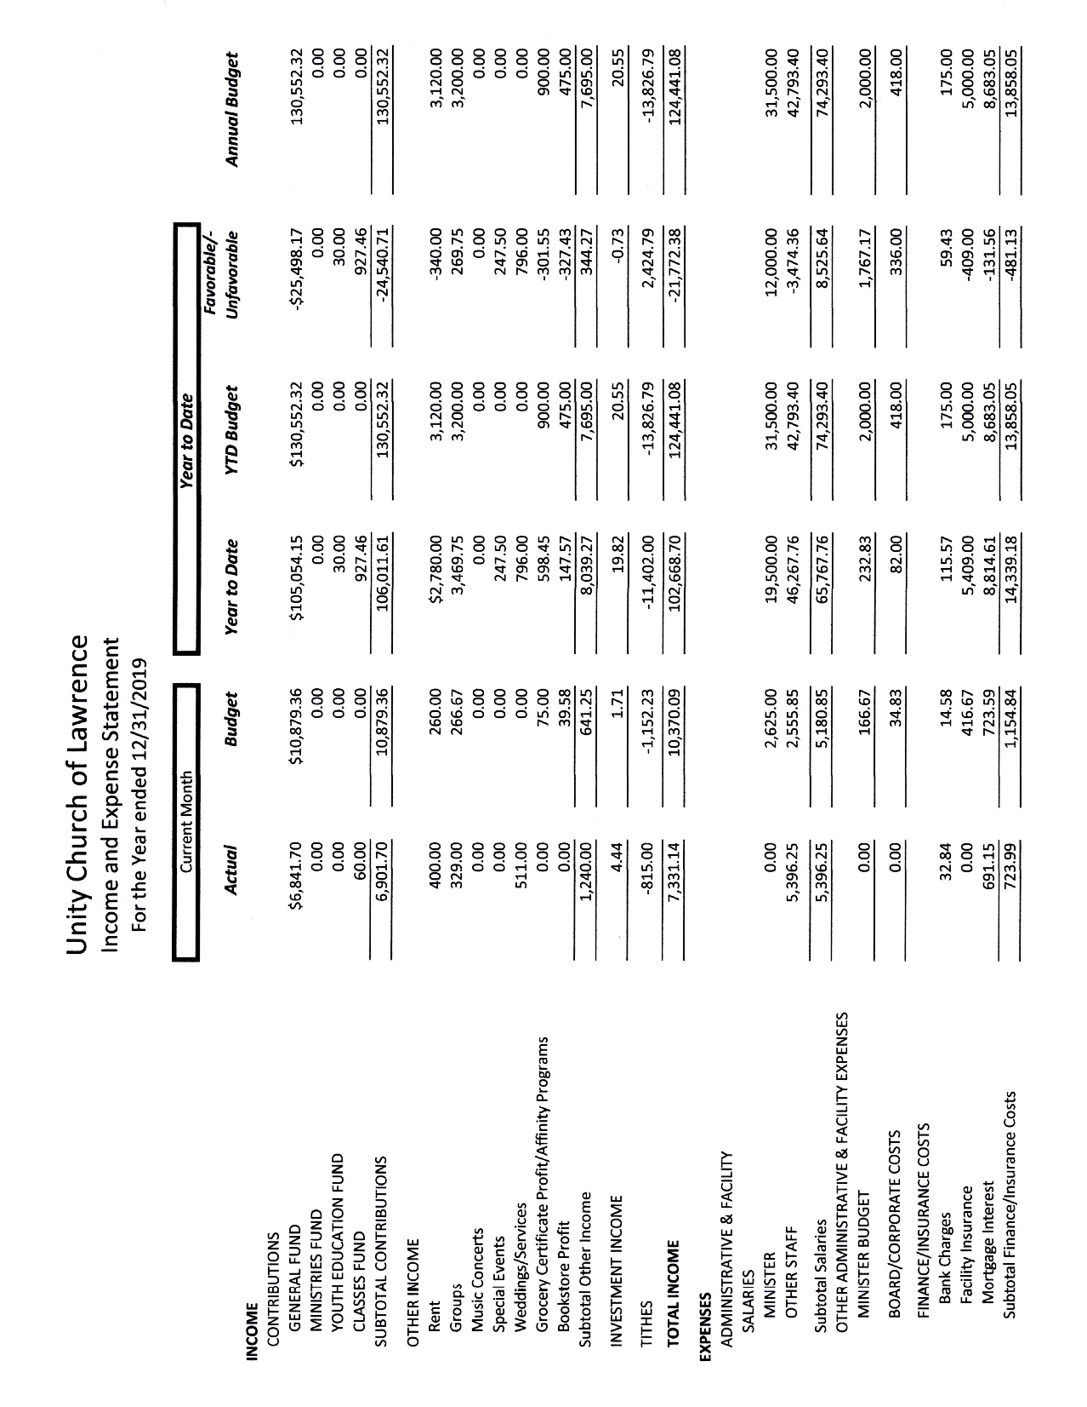
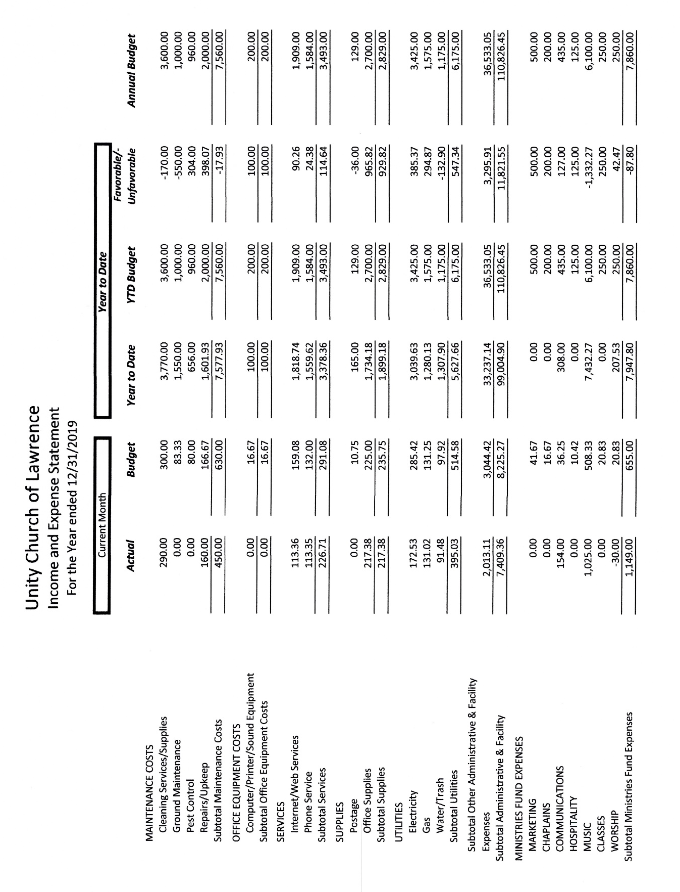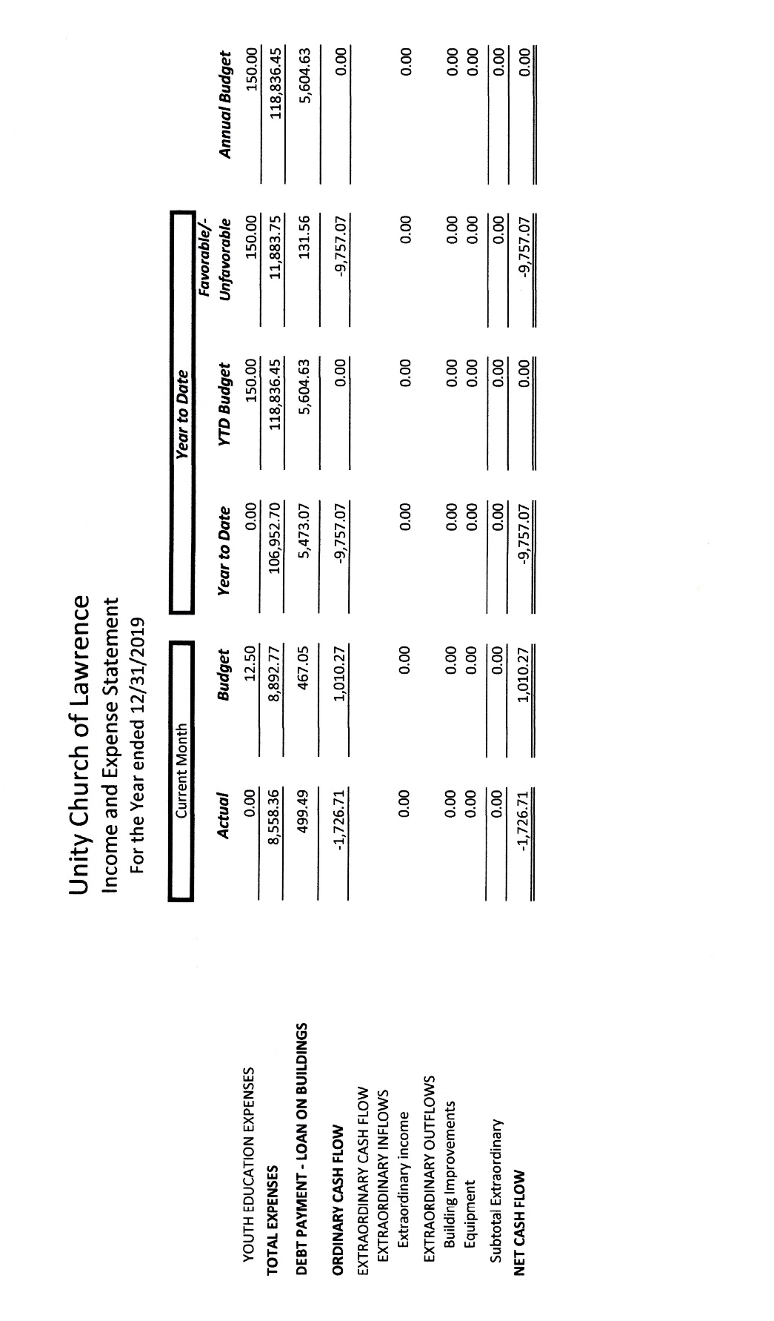

2019 Balance Sheet
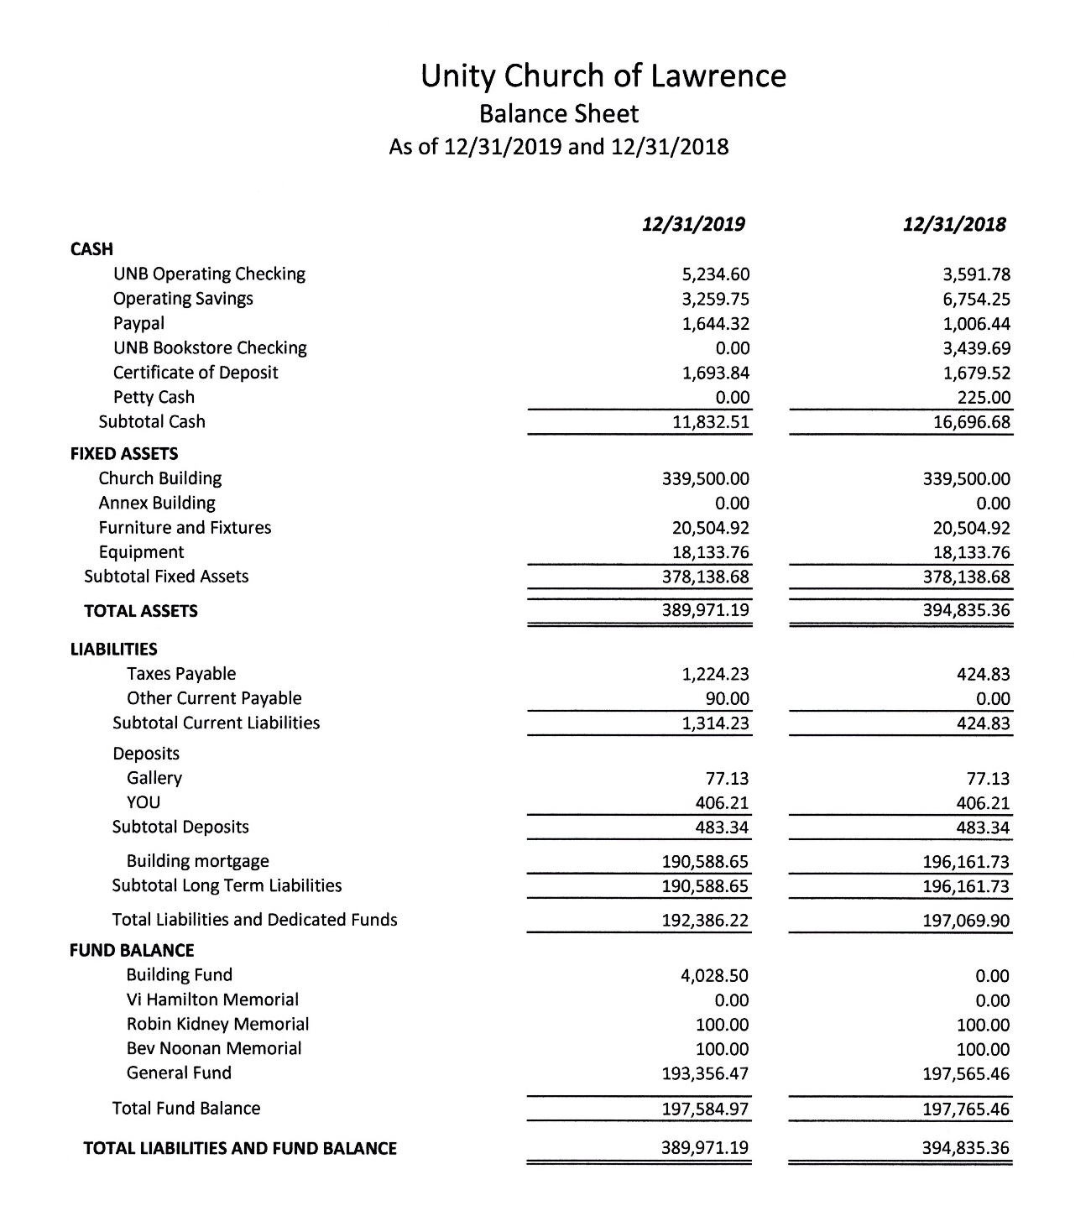

2019 Monthly Income and Expense Summary
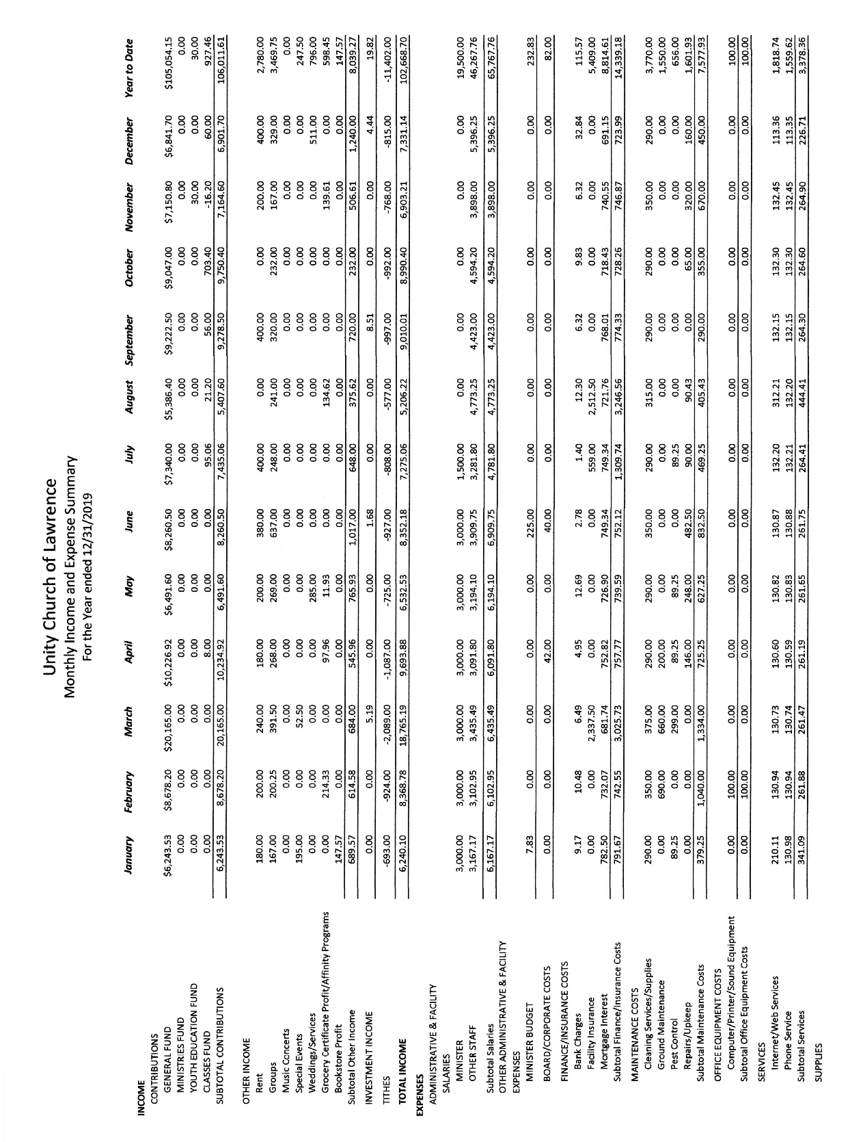
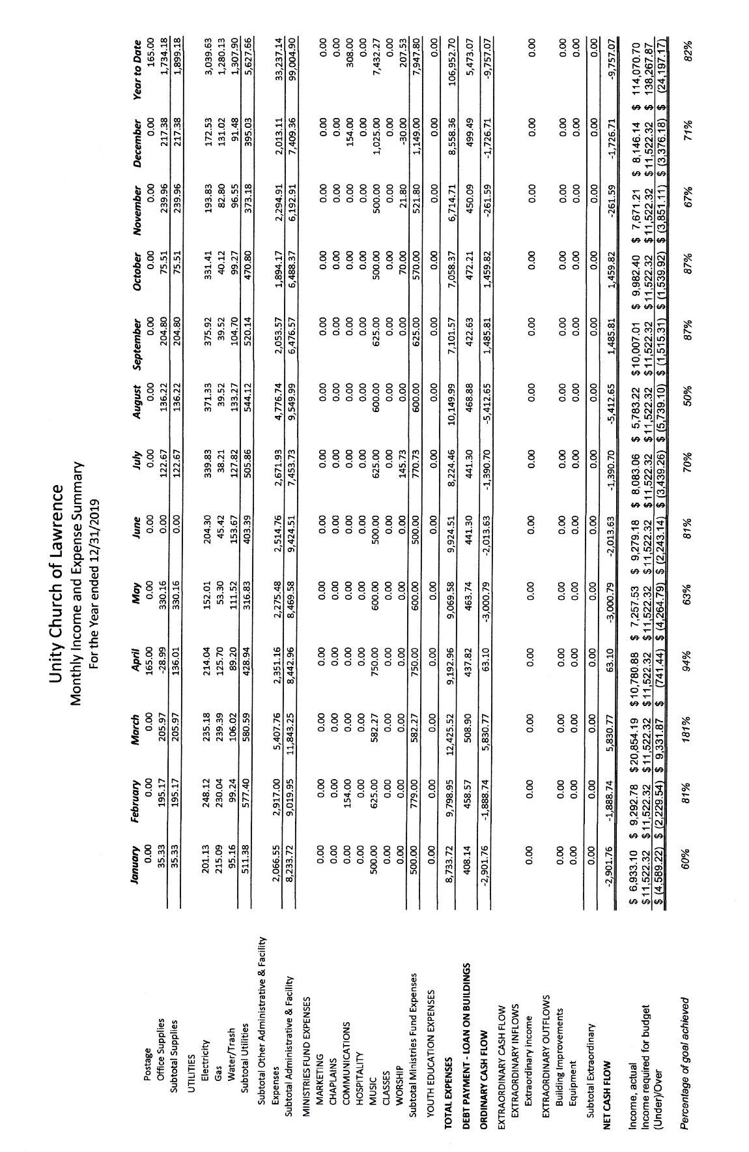

2020 Proposed Budget
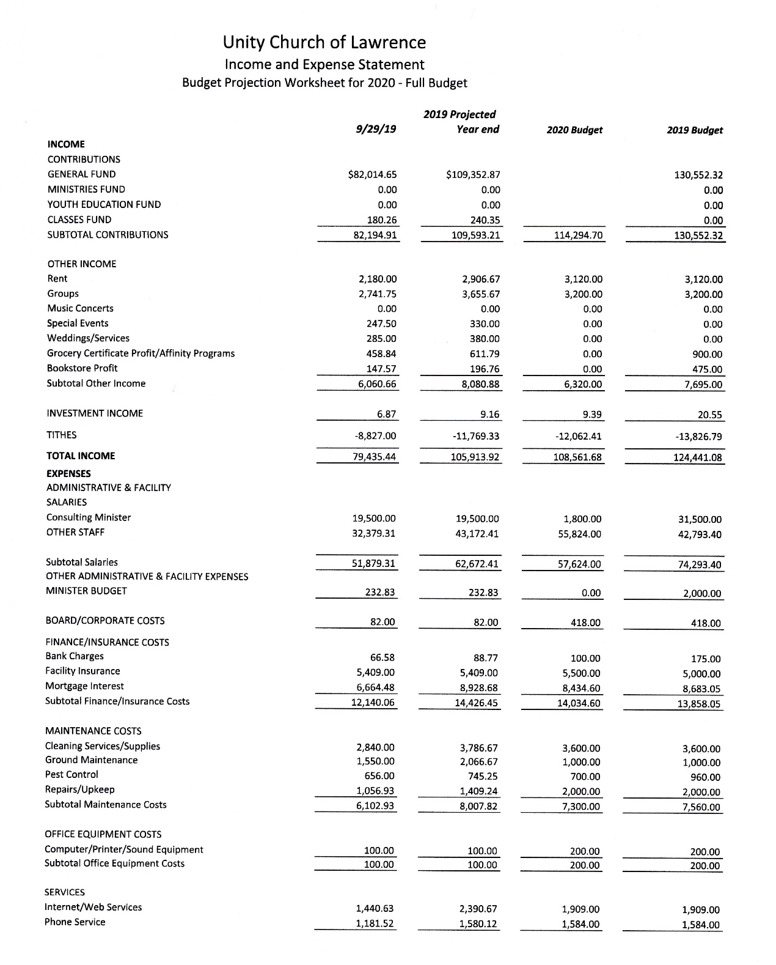

2020 Budget, continued

 

